**APA referencing guide**

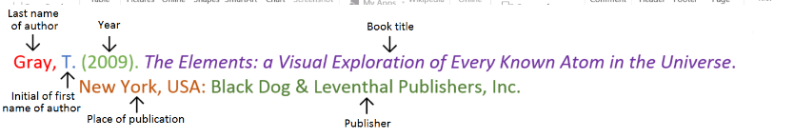**Book**

**Book with two authors**

Shermer, M., & Benjamin, A. (2006). *Secrets of Mental Math: The Mathemagician’s Guide to Lightning Calculation and Amazing Mental Math Tricks*. New York, USA: Three Rivers Press.

**Book with three or more authors**

Bulliet, R. W., Alley, R. B., Broecker, W. S., & Denton, G. H. (2011). *The fate of Greenland: Lessons from abrupt climate change*. Cambridge, MA: MIT Press.

**Book with editor**

Kasdorf, W. E. (Ed). (2003). *The Columbia guide to digital publishing*. New York, USA: Columbia University Press.

**Book with different editions**

Nagle, G., & Cooke, B. (2012). *Geography Study Guide: Oxford Ib Diploma Programme* (2nd ed.). Oxford, UK: Oxford University Press.

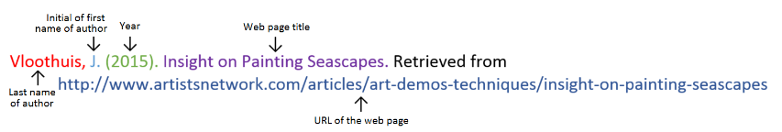**Website**

**Website with no author** (put title of page at the front)

Aranmore Catholic College. (2014). Retrieved from

http://www.aranmore.wa.edu.au/

**Website with no date**

The Zadkine Museum. (n.d). Retrieved http://www.france.fr/en/museums/zadkine-museum.html

**Video file**

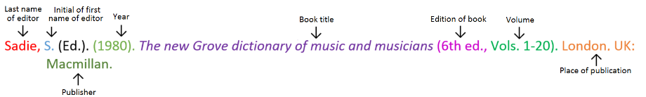**Encyclopaedia or dictionary**

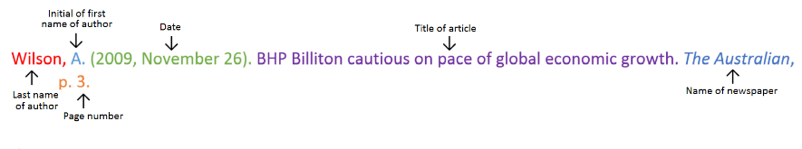**Newspaper article: print**

**Newspaper article: online**

Seelye, K. Q. (2012, December 3). Spate of harsh weather in New England shifts sentiment on trees. *The New York Times.* Retrieved from http://www.nytimes.com